
FRESH TEACHER'S E-LIBRARY
BEGINNING OF TERM III EXAMINATION 2023
PRIMARY ONE
LITERACY 1B

My name is ____________________________________________

I am in _________________________________________________

My school is ___________________________________________

SECTION A
- Write one member of a nuclear family.
__________________________________________________________
- Mention any two important people found at school.
(i)__________________________ (ii) _______________________
- Why do we need class rules?
________________________________________________________
- Draw these items found in a sitting room.
Television | table
- Who heads a school?
__________________________________________________________
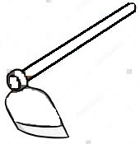
- How are these items useful to people?


_________________________________________________

_______________________________________
_
- Mention two types of seasons.
- ______________________________________________________
- ______________________________________________________
- What name is given to a group of people related by blood
or marriage?
__________________________________________________________
- Draw these types of weather.
sunny | rainy

- Write the people who do this work in our community.
- Treating sick people__________________________________
- Teaching children ____________________________________
- Making furniture _____________________________________
- Give the importance of a clock in the classroom.
__________________________________________________________
- Why do we need guards at school?
__________________________________________________________
- Write the name of your school.
__________________________________________________________
- State one role of children at home.
__________________________________________________________
- Match correctly.
wind used for drying harvested crops.
sun used for watering plants.
rain used for winnowing seeds.
- Name two animals used for transport.
(i)______________________ (ii) ______________________
SECTION B
- Write two activities done at school.
- _________________________ (ii) _______________________
- Draw and name any three things found in a classroom.

- How do farmers care for their plants?
__________________________________________________________
- Who breastfeeds the baby at home?
__________________________________________________________
- Give two uses of trees in our school compound.
- ______________________________________________________
- ______________________________________________________
- Name the item below used for managing sun weather.
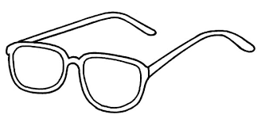 | 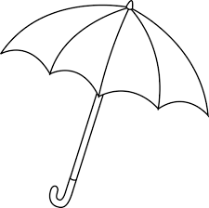

- Write one bird kept at home for eggs.
__________________________________________________________

- Name these important people found in a community.
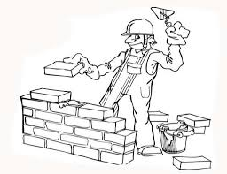 | 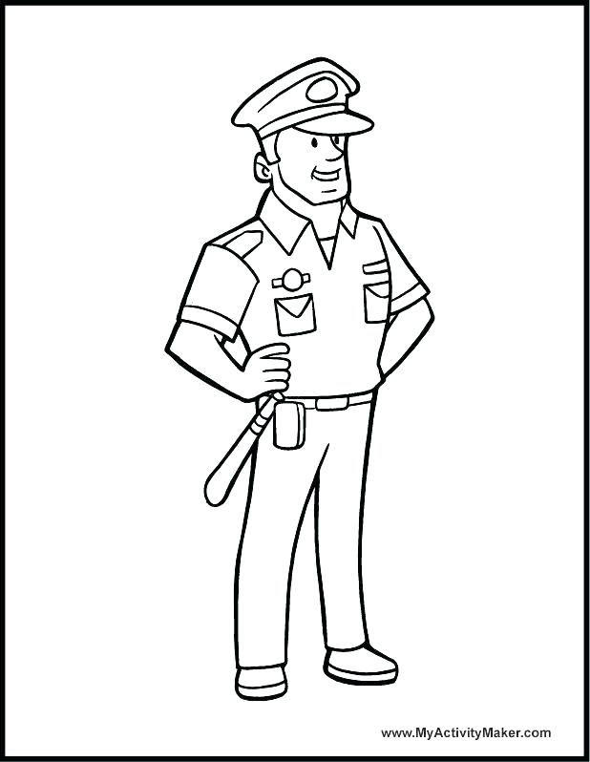

- Name two play objects found at school.
- _____________________ (ii) _______________________
- Write one member of an extended family.
__________________________________________________________
- Why do we need a school gate?
__________________________________________________________
- Name two things made by a carpenter.
- ___________________________________________________
- ____________________________________________________
- Give two things we use to keep our classroom clean.
- ________________________ (ii) _______________________
- Write one role of a father at home.
__________________________________________________________
- What name is given to a place where people live?
__________________________________________________________
- Which animals are kept at home for milk?
- _______________________ (ii) _______________________
*********************END***********************

